Assignment 4 - Classic Concert / ESPORT Event Poster /20pts

There are a lot of people around the world who collect concert and event posters and no doubt someone will want to add your poster to their collection.
Concert posters advertise everything a person needs to know but also, in an artistic way.
Here are some things you will want to include in your poster.
- Images of the musical or Esports acts and hosts
- The Date and Time of the fake show
- The Location of the fake show
- The NAME of the fake festival (large)
- The NAMES of the four musical acts (Listed) Headliner on top and all others under
-The PRICE - Important Rules (smaller)
- A MAP to the location (image from internet or drawing)
- YOUR WEBSITE ADDRESS (what www.something.com would you use?)
- Fake Social Media Info ( Twitter and Facebook and Insta)

Huge Tips:
- Canva can erase the background of most images (Ask Mr. Kelly)
- Canva has millions of elements you can add to make your poster wicked awesome
- You can share your project with your teacher from the top right corner of Canva (super fast)
Example Concert Posters
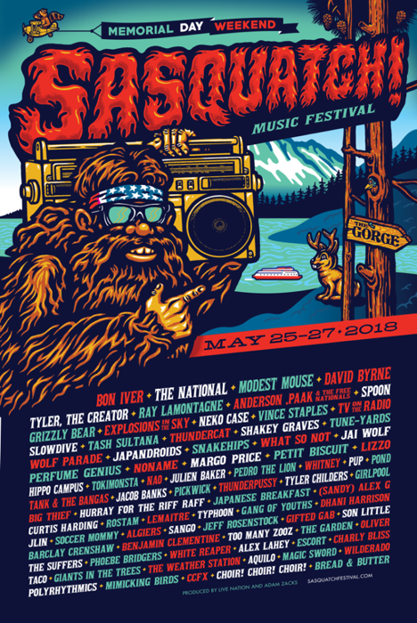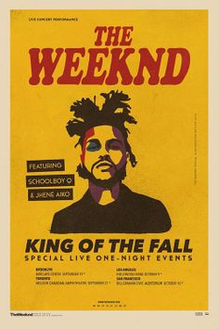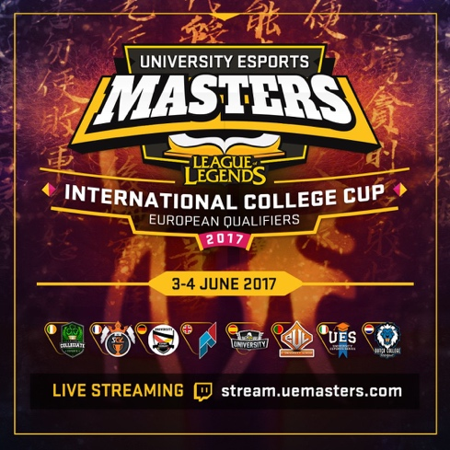

Can you take the heat? Make your Event poster EPIC!

