Grade 8 Digital Citizenship Assignments – Digital Communication

8 questions, 3 acronyms and an official email to Mr. Kelly in this assignment

1.What is the definition of digital communication? (1)

2. List 4 digital communication advantages and 4 disadvantages in your opinion. (8)

3. What are the three most popular forms of digital communication today and why do you think they are popular? (4)

4. What three forms of digital communication may not be around much longer and why do you think they are going to disappear or become irrelevant? (4)

5. Can you list five locations or scenarios in real life where you really SHOULD NOT be communicating digitally and suggest WHY? (5)

6. Spend some time online researching dangerous digital communication then answer: In your mind which TWO forms of digital communication represent the greatest DANGER to your personal health and safety and WHY? (4)

7. Do you think human kids will continue to be more and more connected or will people eventually find their own healthy balance? Why? (2)

8. When a person dies, is too sick or injured to communicate or for any other reason avoids all digital communication; what should happen to their accumulated online communications and records of internet activity? What is your solution to this growing problem? Ex. If someone passes away and they have Facebook, Twitter, Websites, Cell Phones what should be done and who should be responsible to do it?

PART 2: Acronyms (Using and creating acronyms or initialisms)

Check out this amazing list of acronyms and initialisms THEN make up THREE (3) NEW school appropriate ACRONYMS and list them with their meaning
https://bbtnb.cdxauto.ca/pluginfile.php/126/mod_page/content/14/digcitacro.pdf

Part 3: Send Mr. Kelly an email about a fake concern but structure it properly like this:
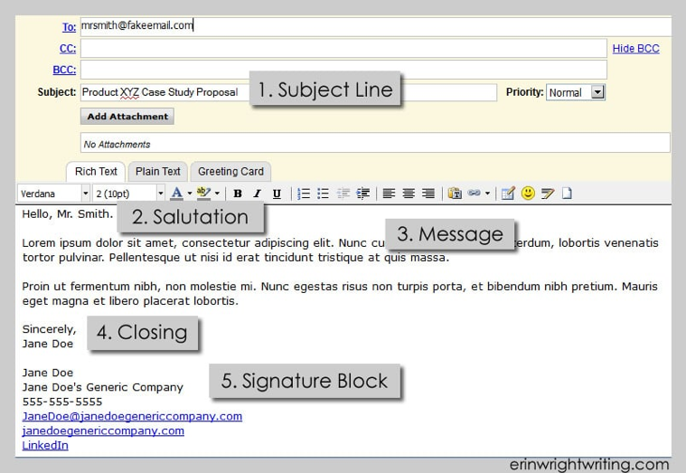
Subject: What’s the email about

Salutation: The greeting

Message: The message or background info (get to the point)

Closing: What you are looking for, next actions requested

Signature: Your name and any other details

