Grade 8 Digital Citizenship Assignment 2: Digital Security /20pts
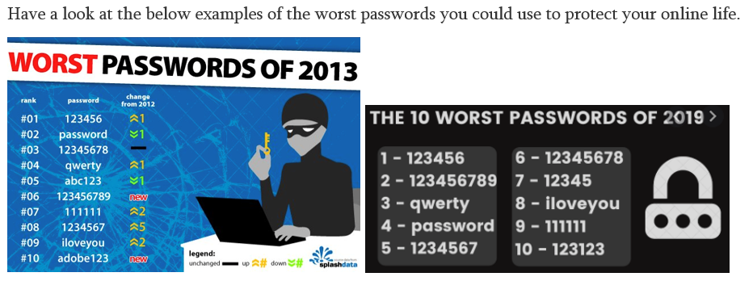
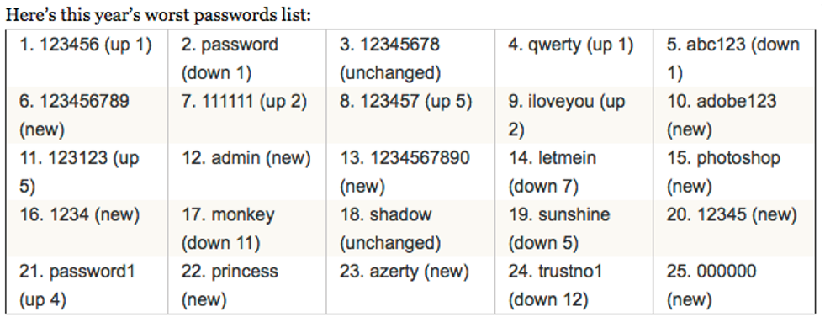
Viewing the two worst passwords lists on the bbtnb.ca website under digital security answer the following questions:
1.Would you say the passwords listed as the worst are easy to guess or hard to guess and why?

2.Have you ever used any of these passwords? If yes how do you feel about this list? If NO why not?

3.Do you think seniors and adults are more likely to use these passwords? What can we do to save them some disastrous consequences if they do?

4.Can you think of three extra horrible passwords not found on this list?

5.How long should a modern password be to be called strong? (This might be a trick quest)

6.If you are using any passwords similar to these make sure to go home tonight or use some time right now to change these passwords to something less risky and more secure. THIS IS IMPORTANT HOMEWORK !
Part 2: STONG PASSWORDS FOR 2023 and Beyond
NOTES TO READ: A modern STRONG password is not a single word, it is not a word with numbers, it is a FULL SENTENCE complete with the following:
Capital and lowercase lettering and Symbols and Numbers
Here is an example:
Sentence " Toronto Maple Leafs lose forever kids"
Now that would be a pain to peck into a smartphone over and over so let's shorten it and strengthen it at the same time.
TMLLose4evakids - it is long enough but still just letters and numbers
Let's make the S a $ sign and the letter "e" let's flip into a number 3 (backwards E)
TMLLo$343vaKid$ - Now this is a very very strong password that Microsoft would call "BEST". All you have to do is remember what the sentence says and spot where you may have tweaked it. Computers can still crack this but it would take FAR TOO LONG and so they would just move on to a new target.
FINAL CHALLENGE:
Go to the link below and type in your passwords you use for
SNAPCHAT, TikTok, Youtube, Facebook XBOX, INSTA
It will give you an honest score about how fast you account can be hacked and the strength of your passwords. Tell Mr. Kelly how well you did.
PASSWORD CHECKER (Hold CTRL and click on link): Password Check | Kaspersky

